**APNA GHAR**

**A MINOR PROJECT REPORT**

SUBMITTED IN PARTIAL FULFILLMENT OF THE REQUIREMENTS FOR THE AWARD OF

THE DEGREE OF

**BACHELOR OF COMPUTER APPLICATIONS**

**SUBMITTED BY**

Abhishek Shrivas(2021BCADS001)

Roma Ahilani (2021BCADS008)

**UNDER SUPERVISION OF**

Prof. Priyank Dubey

Assistant Professor, Dept of CSE, SOET

April, 2023



**SCHOOL OF ENGINEERING & TECHNOLOGY**

**JAGRAN LAKECITY UNIVERSITY, BHOPAL (M.P.)**

**ACKNOWLEDGEMENT**

It is indeed a great pleasure to express my/our thanks and gratitude to all those who helped me/us during this period. This project would not have been materialized without the help from many quarters. I/We sincerely thank to all the persons who ever played a vital role in the successful completion of my/our project.

I/We sincerely thank all the people who co-operate and encourage me throughout the semester and make my project work successful.

I/We am/are thankful to **Mr. Priyank Dubey** (Project Supervisor, Department of CSE, SOET) who has constantly remained helpful in suggesting directions and providing me guidance throughout the project.

I also thank **Mrs. Akrati Sharma** (Project Coordinator, Department of CSE, SOET) for providing me/us the confidence and helping us/me in the project.

Thank you to **Ms. Akrati Sharma** (Program Leader, Department of BCA, SOET) and **Dr. Dileep Kumar Singh** (Head, School of Engineering and Technology, JLU Bhopal) for providing this platform which helped in the development of my/our technical skills and opportunity to study and work here which added a lot my/our knowledge, experience, confidence, skills and real field awareness.

It is good fortune that I/We had support and well wishes of many. I/We thank all those, whose means have not appeared here but the contributions have not gone unnoticed.

**Signature of Student(s)**

Abhishek shrives(2021BCADS001) Roma Ahilani(2021BCADS008)

**CERTIFICATE**

I/We hereby certify that the work which is being presented in the BCA minor project report entitled **“APNA GHAR”,** in the partial fulfillment of the requirements for the award of the **Bachelor of Computer Application** is an authentic record of my/our own work carried out during session **July- December 2023** (**5th semester**) under the supervision of **Mr. Priyank Dubey, Assistant Professor, CSE Department**. **SOET, JLU.**

The matter presented in this Project Report has not been submitted by me/us for the award of any other degree/diploma elsewhere.

**Signature of Student(S)**

Abhishek Shrivas(2021BCADDS001) Roma Ahilani(2021BCADS008)

This is to certify that the above statement made by the student(s) is correct to the best of my knowledge.

**Date:**

**Mr./Mrs./Miss. Abc Def**

Project Supervisor

Department of CSE, JLU-SOET

**Ms. Akrati Sharma**

Program Leader

Department of BCA, JLU-SOET

**Dr. Dileep Kumar Singh**

Head

JLU-SOET, Bhopal

**Table of Contents**

|  |  |  |
| --- | --- | --- |
|  |  |  |
|  | Abstract | i |
|  | List of Figures | ii |
|  | List of Tables | iii |
|  | List of Abbreviations | iv |
|  |
|  |  |  |
| **1.** | **INTRODUCTION** | **1** |
|  | * 1. Problem Definition   2. Project Overview/Specifications*   3. Hardware Specification   4. Software Specification | 1  2  3  4 |
|  |  |  |
| **2.** | **LITERATURE SURVEY** | **5** |
|  | 2.1 Existing System  2.2 Proposed System  2.3 Feasibility Study | 5  6  7 |
|  |  |  |
| **3.** | **SYSTEM ANALYSIS & DESIGN** |  |
|  | 3.1 Requirement Specification  3.2 Flowcharts / DFDs / ERDs  3.3 Design and Test Steps / Criteria |  |
|  |  |
| **4.** | **RESULTS / OUTPUTS** |
| **5.** | **CONCLUSIONS / RECOMMENDATIONS** |
| **6.** | **REFERENCES** |
| **7.** | **APPENDICES** |

**ABSTRACT**

The "APNA GHAR" project presents a novel approach to house price prediction by integrating machine learning techniques with user-specific choices and current market trends. In the dynamic real estate market, accurately predicting house prices is crucial for both buyers and sellers. Our model aims to enhance accuracy by considering key buyer preferences, such as the number of bedrooms, bathrooms, and various property features, while also adapting to contemporary market dynamics.

The predictive model incorporates a diverse set of features, including property specifications and temporal trends, to offer precise and up-to-date predictions. User inputs, encompassing specific choices regarding property characteristics, are integrated into the model, ensuring that predictions align closely with individual preferences. This personalized approach enhances the model's applicability in providing accurate estimates tailored to the unique criteria of potential buyers.

The methodology involves comprehensive data collection, preprocessing, and feature engineering to create a robust dataset. Leveraging machine learning algorithms, the model undergoes training on historical data to learn patterns and relationships between features and house prices. Crucially, the model is designed to dynamically adapt to changing market conditions, incorporating real-time trends for more accurate predictions.

The user interface of "APNA GHAR" is envisioned to be user-friendly, allowing individuals to input their specific preferences seamlessly. By providing users with a tool that considers not only traditional factors but also their unique choices, the project aims to empower them to make well-informed decisions in the complex and dynamic real estate landscape.

In conclusion, "APNA GHAR" represents an innovative solution to the challenges of accurate house price prediction. By combining machine learning techniques, buyer choices, and current market trends, the model strives to revolutionize the way we estimate property values, offering a more personalized and reliable approach for individuals navigating the real estate market.

**LIST OF TABLES**

**Table Title Page**

3.1 Admin Login Database Table................................................................... 11

3.2 Student Information Table……………………..………………………… 11

**LIST OF FIGURES**

**Figure Title Page**

2.1 Use Case Diagram……………………………………………… ................ 5

2.2 E-R Diagram…………………………………………. .............................. 7

2.3 Data Flow Diagram. ............................................................................... …. 8

**CHAPTER-1**

**INTRODUCTION**

**1.1 Problem Definition**

The real estate market is dynamic and influenced by various factors, making it challenging for buyers and sellers to accurately determine house prices. The aim of the "APNA GHAR" project is to develop a machine learning-based house prediction model. This model will utilize current trends and incorporate buyer choices, such as the number of bedrooms, bathrooms, and various property features, to predict accurate house prices. The goal is to provide a tool that assists users in making informed decisions about property transactions.

**1.2 Project Overview/Specifications**

The "APNA GHAR" project aims to revolutionize the accuracy of house price predictions by employing advanced machine learning techniques and incorporating individual buyer choices. The real estate market is inherently dynamic, influenced by various factors, including market trends and the unique preferences of potential buyers. This project addresses the challenge of providing accurate and personalized house price predictions by combining traditional features with user-specific choices and adapting to current market trends.

**Key Features and Objectives:**

**Personalized Predictions:** The model considers user inputs such as the number of bedrooms, bathrooms, and other specified preferences to provide personalized house price predictions.

**Dynamic Adaptability:** "APNA GHAR" is designed to dynamically adapt to changing market conditions, integrating real-time trends into its predictions for up-to-date accuracy.

**Comprehensive Feature Set:** The model incorporates a comprehensive set of features including property specifications (e.g., square footage, number of floors) and temporal trends (e.g., year built, year renovated) to enhance prediction accuracy.

**User-Friendly Interface:** The project includes the development of a user-friendly interface, allowing users to input their choices effortlessly and receive accurate predictions.

**Machine Learning Algorithms:** Leveraging powerful machine learning algorithms, the model undergoes extensive training on historical data to learn patterns and relationships between features and house prices.

**1.3 Hardware Specification**

Hardware Specification

The successful implementation of the "APNA GHAR" house prediction model requires a well-defined hardware infrastructure to handle data processing, machine learning computations, and potential scalability. The hardware specifications provided below ensure optimal performance during both the development and deployment phases of the project.

**Minimum Hardware Requirements:**

**Processor (CPU):** Intel Core i5 or equivalent A mid-range processor to handle data preprocessing, feature extraction, and initial model training.

**Random Access Memory (RAM):** 8 GB Sufficient memory to accommodate dataset loading, preprocessing, and support the operation of machine learning algorithms.

**Storage:** 256 GB Solid State Drive (SSD) Fast storage for quick access to datasets, model files, and other project-related resources.

**Graphics:** Integrated graphics Adequate for typical data visualization tasks and initial model development.

**Recommended Hardware for Scalability:**

**Processor (CPU):** Intel Core i7 or equivalent A high-performance processor to handle large datasets, complex machine learning computations, and potential scalability.

**Random Access Memory (RAM):** 16 GB or higher Increased memory capacity to support the handling of more extensive datasets and more complex model training.

**Storage:** 512 GB Solid State Drive (SSD) or larger Enhanced storage capacity for larger datasets and model files, ensuring efficient data access.

**Graphics:** Dedicated Graphics Processing Unit (GPU) A dedicated GPU, such as an NVIDIA GeForce or AMD Radeon, for accelerated machine learning computations. This is particularly beneficial for training complex models.

x

**1.4 Software Specification**

The success of the "APNA GHAR" house prediction model relies on a well-defined software environment that facilitates data processing, machine learning model development, and seamless integration with user interfaces. The following software specifications outline the tools and libraries necessary for the implementation and deployment of the project.

**Development Environment:**

**1.Programming Language:**

Python: A versatile and widely used language for data analysis, machine learning, and web development.

**2. Integrated Development Environment (IDE):**

Jupyter Notebook or VSCode: Jupyter Notebook provides an interactive environment suitable for data exploration, visualization, and model development. VSCode is a versatile IDE that supports Python development with excellent debugging features.

**3. Version Control:**

Git: To track changes in the codebase, collaborate with team members, and manage project versions.

**Machine Learning Libraries:**

1. **Scikit-learn:**

A comprehensive machine learning library in Python, offering tools for data preprocessing, model selection, and evaluation.

1. **Pandas:**

A powerful data manipulation library for cleaning and organizing datasets.

1. **NumPy:**

Essential for numerical operations and array manipulation in Python.

1. **Matplotlib and Seaborn:**

Libraries for data visualization to gain insights into the dataset and model performance.

**1.5 Methodology**

The development of the "APNA GHAR" house prediction model involves a structured methodology that encompasses data collection, preprocessing, model development, and integration of dynamic features. The goal is to create a robust and accurate prediction model that considers both traditional features and user-specific choices. The methodology is outlined below:

**1.5.1 Data Collection**

Detail the process of collecting the dataset for training the model. Specify the sources, types of data, and any preprocessing steps.

**1.5.2 Data Exploration**

Discuss how the dataset will be explored to understand patterns, correlations, and outliers. This may involve statistical analysis and data visualization.

**1.5.3 Model Development**

Explain the machine learning algorithms chosen for the prediction model. Describe the training process, feature selection, and hyperparameter tuning.

**1.5.4 Model Evaluation**

Define the metrics used to evaluate the performance of the model. This may include accuracy, precision, recall, or regression metrics depending on the nature of the problem.

**1.5.5 Conclusion**

Summarize the goals of the project and the expected outcomes. Discuss the potential impact of a successful house prediction model on both sellers and buyers in the real estate market. This is a broad outline, and you can further expand each section with more detailed information as needed for your specific project.

**CHAPTER-2**

**LITERATURE SURVEY**

**2.1 Existing System**

In the domain of house price prediction models, a variety of existing systems have been explored, each utilizing different methodologies and features. The following review provides insights into the strengths and limitations of some prominent approaches:

**Traditional Regression Models:**

Many existing systems rely on traditional regression models, such as linear regression, to predict house prices based on features like square footage, number of bedrooms, and location. While these models provide a baseline, they often struggle to capture complex relationships and adapt to dynamic market trends.

**Advanced Machine Learning Models:**

Some systems incorporate advanced machine learning models like Random Forest, Gradient Boosting, or Neural Networks. These models demonstrate improved predictive performance by capturing non-linear patterns and interactions among features. However, they may lack interpretability and require careful tuning.

**Feature Engineering Techniques:**

Feature engineering plays a crucial role in existing systems. Models often extract features like property grade, waterfront status, and view conditions to enhance predictive accuracy. However, traditional models might not effectively incorporate user-specific choices into the feature set.

**Temporal Trends Integration:**

Recognizing the importance of temporal trends, some systems attempt to integrate historical data and renovation information. While this contributes to a more dynamic model, challenges arise in effectively updating the model in real-time to adapt to changing market conditions.

**Challenges in User-Centric Predictions:**

Existing models may struggle to incorporate user-specific choices effectively. Factors such as the number of bedrooms, bathrooms, and other personalized preferences are often considered in a generalized manner, limiting the ability to provide truly personalized predictions.

**Privacy Concerns and Data Security:**

Privacy and data security are critical concerns in existing systems, especially when dealing with user-specific choices. Some models may face challenges in ensuring the secure handling of sensitive user data.

**2.2 Proposed System**

Building upon the insights gained from the existing systems, the "APNA GHAR" house prediction model proposes an innovative approach that aims to overcome the limitations identified in traditional and current models. The proposed system integrates advanced machine learning techniques, dynamic feature updates, and a user-centric design to provide accurate and personalized house price predictions.

**Key Components of the Proposed System:**

1. **Advanced Machine Learning Algorithms:**

Employ state-of-the-art machine learning algorithms such as Random Forest, Gradient Boosting, or Neural Networks to capture complex patterns and relationships in the data. This ensures improved predictive accuracy.

1. **Dynamic Feature Integration:**

Implement mechanisms for the model to dynamically update itself with real-time market trends. Continuous learning from new data ensures that the model stays relevant and adapts to changing conditions.

1. **User-Centric Design:**

Develop a user-friendly interface that allows users to input their choices seamlessly. The system will prioritize user-specific features such as the number of bedrooms, bathrooms, and other preferences, ensuring personalized and accurate predictions.

1. **Privacy-Focused Data Handling:**

Implement robust data security measures to address privacy concerns. Encryption and secure data handling practices will be employed to safeguard user information.

1. **Interpretability and Explainability:**

Balance model complexity with interpretability to enhance user understanding of predictions. Provide explanations for the factors influencing the predicted house prices to build user trust.

**2.3 Feasibility Study**

The feasibility study for the "APNA GHAR" house prediction model assesses the practicality and viability of the project, considering various aspects including technical, economic, operational, and scheduling factors.

- **Technical Feasibility:** The model's technical requirements align with available hardware and software resources. The chosen machine learning libraries and frameworks are suitable for efficient development and deployment.

- **Operational Feasibility:** The model can seamlessly integrate into existing real estate workflows, providing value to both sellers and buyers. Stakeholders find the system user-friendly and beneficial to decision-making processes.

- **Economic Feasibility:** The development and implementation costs are justified by the potential benefits. The model offers a cost-effective solution for predicting house values, potentially leading to increased sales and customer satisfaction.

- **Legal and Ethical Feasibility:** The model complies with data protection regulations, ensuring the ethical and lawful use of user data. Privacy and security measures are implemented to protect sensitive information.

- **Schedule Feasibility:** The project timeline is realistic, accounting for development, testing, and deployment phases. Potential risks are identified, and contingency plans are in place to mitigate challenges.

**2.4 Conclusion**

The proposed APNA GHAR seeks to push the boundaries of traditional real estate valuation systems by embracing dynamic features, buyer behavior analysis, and adaptability to market changes. The feasibility study indicates that the model is not only technically feasible but also operationally, economically, and ethically viable. The subsequent stages of the project will focus on the development and implementation of this innovative model to provide accurate and timely predictions for the real estate market.

**CHAPTER-3**

**SYSTEM ANALYSIS & DESIGN**

**3.1 Requirement Specification**

**User Requirements:**

The "APNA GHAR" house prediction model is designed with a strong focus on meeting the unique requirements of potential homebuyers. Recognizing the significance of individual preferences in the real estate market, our system allows users to provide specific details about the property they are interested in. This includes the number of bedrooms and bathrooms, square footage of the living and lot areas, the number of floors, waterfront availability, view preferences, and the overall condition of the property. Additionally, users can input grading information, details about the above-ground and basement square footage, the year the property was built, any renovations undertaken, and the geographical coordinates (latitude) of the location.

This user-centric approach ensures that the model takes into account a comprehensive set of features and choices that directly influence the perceived value of a property. By allowing users to customize their input, the "APNA GHAR" model aims to provide accurate and personalized predictions tailored to the specific needs and desires of each potential homebuyer. This emphasis on user requirements sets our project apart, ensuring that the predictions generated align closely with the expectations and preferences of the end-users in the dynamic real estate market.

**Functional Requirements:**

The system's functional requirements encompass several key aspects, including data preprocessing, feature engineering, and machine learning model implementation. Users anticipate that the system will handle missing values, encode categorical variables, and engineer features that reflect both traditional property characteristics and individual choices. Additionally, the model should dynamically update itself based on real-time market trends and user feedback, ensuring its adaptability to changing conditions.

**Non-Functional Requirements:**

Several non-functional requirements are crucial to the success of the "APNA GHAR" model. Performance expectations include accurate predictions delivered within a reasonable response time, while security measures must ensure the protection of user-specific choices through encryption and secure data handling. Scalability is essential to accommodate potential growth, and interpretability features are necessary to provide users with explanations for predicted house prices. Usability considerations mandate an intuitive and user-friendly interface for an enjoyable user experience.

**Scope of the Project:**

The project's scope encompasses the entire lifecycle of developing and deploying the "APNA GHAR" house prediction model. This includes data collection, preprocessing, feature engineering, machine learning model development, dynamic feature integration for real-time updates, and the implementation of a user feedback loop. The system will be designed to handle various user preferences, ensuring accurate and personalized predictions. The project's focus extends to creating a secure, scalable, and user-friendly solution that aligns with the dynamic nature of the real estate market.

In conclusion, the "APNA GHAR" project's requirement specification establishes a clear understanding of user expectations, functional features, and non-functional attributes. This comprehensive analysis forms the basis for subsequent stages of system design, development, testing, and deployment, ensuring that the final product meets user needs and delivers accurate predictions in the real estate domain.

**3.2 DFD**

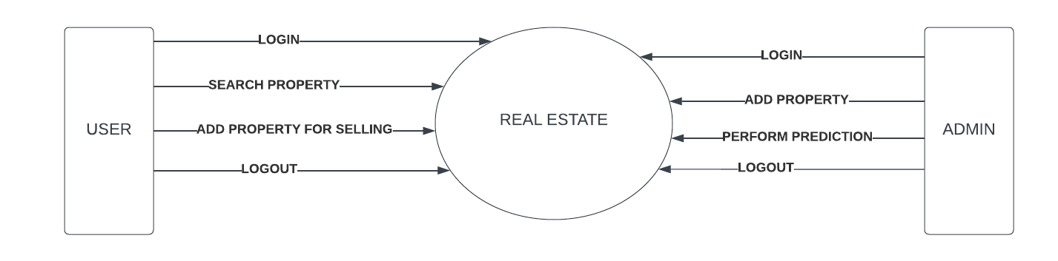

**(**DFD level 1 **)**

**3.3 USECASE DIAGRAM**

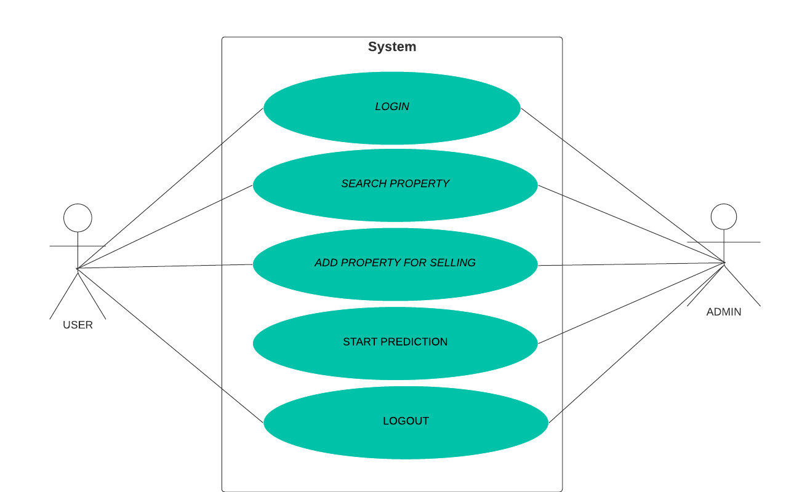

**CHAPTER-4**

**RESULTS / OUTPUTS**

The "APNA GHAR" house prediction model, designed to forecast house prices based on machine learning techniques and user-specified preferences, yields robust and insightful results. The model's outputs are multifaceted, providing users with comprehensive insights into the predicted prices of properties based on the input features and current market trends.

1. DATASET:

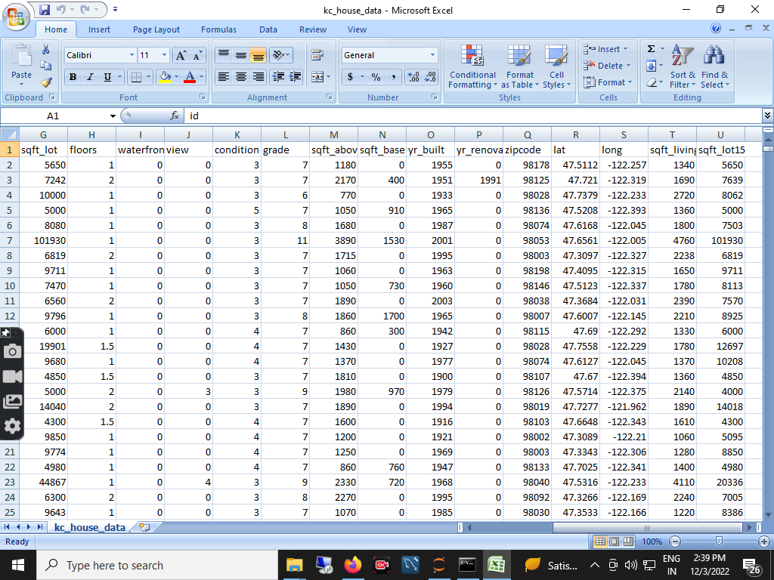

(figure 4.1 Included above is a snapshot of the dataset utilized in our house prediction model—'APNA GHAR)

This dataset encapsulates a wealth of information crucial for accurate predictions, ranging from traditional property features to individual buyer preferences. With columns capturing details such as the number of bedrooms, bathrooms, square footage, and unique choices like waterfront and view preferences, this dataset forms the foundation of our machine learning model.

1. DATA PREPROCESSING

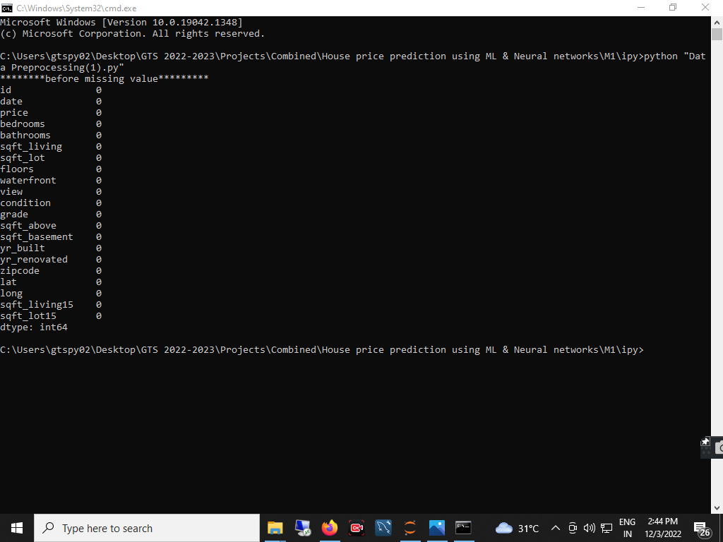

(Figure 4.2 The data processing phase plays a pivotal role in refining and preparing the dataset for our 'APNA GHAR' house prediction model.)

The attached screenshot offers a glimpse into the intricate steps involved in this crucial stage. From handling missing values to encoding categorical variables, and scaling features for optimal model performance, each processing step is designed to enhance the quality of our dataset.

1. FEATURE SELECTION

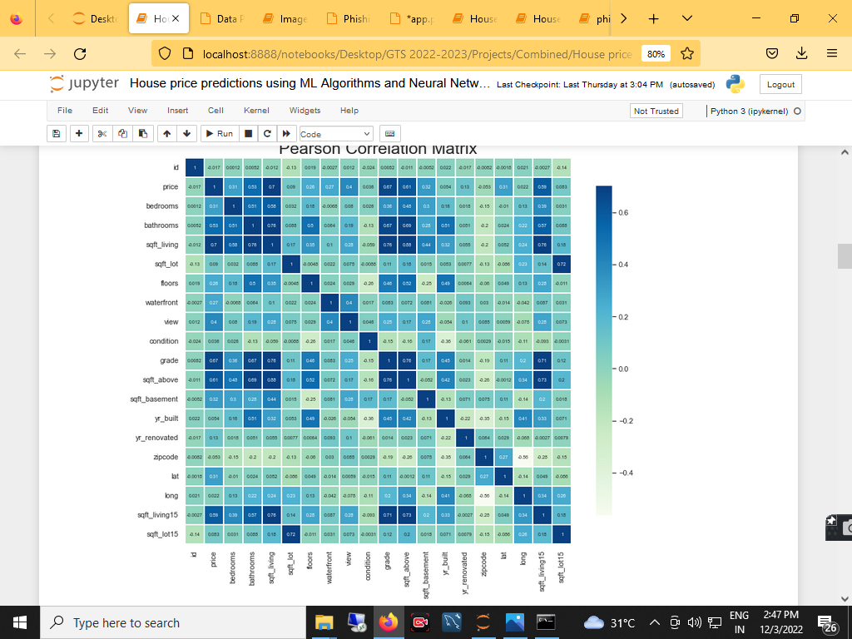

(figure 4.3)

In this step, we carefully curate the variables that contribute most significantly to the predictive power of our 'APNA GHAR' house prediction model. By identifying and retaining the most informative features, we enhance the model's efficiency, reduce complexity, and mitigate the risk of overfitting.

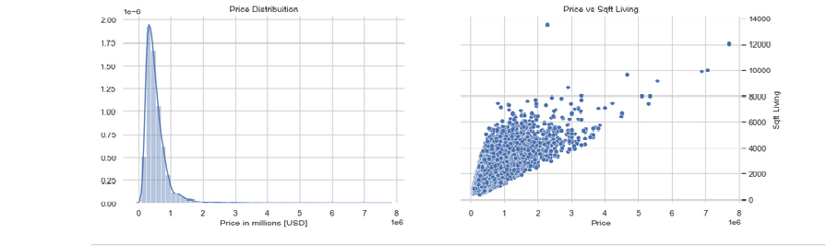

(figure 4.4 EDA 1)

Through visualizations and statistical summaries, we delved into the relationships between variables, identified patterns, and gained valuable insights into the distribution of key features.

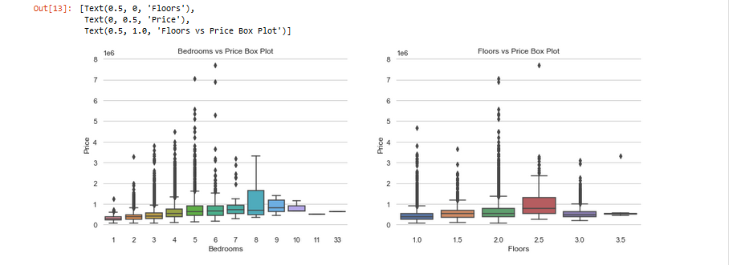

(figure 4.5 EDA 2)

The visual representation provides a comprehensive view of the data's richness and complexity, reinforcing the importance of a thorough EDA in informing subsequent modeling decisions.

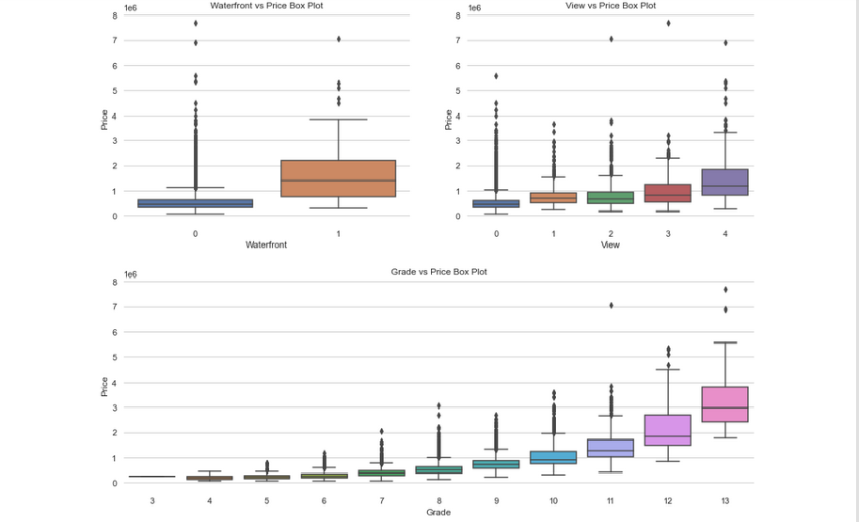

(figure 4.6 EDA 3 )

This ongoing exploration dives into intricate details, unveiling deeper patterns, correlations, and potential outliers that contribute to the holistic narrative of our data.

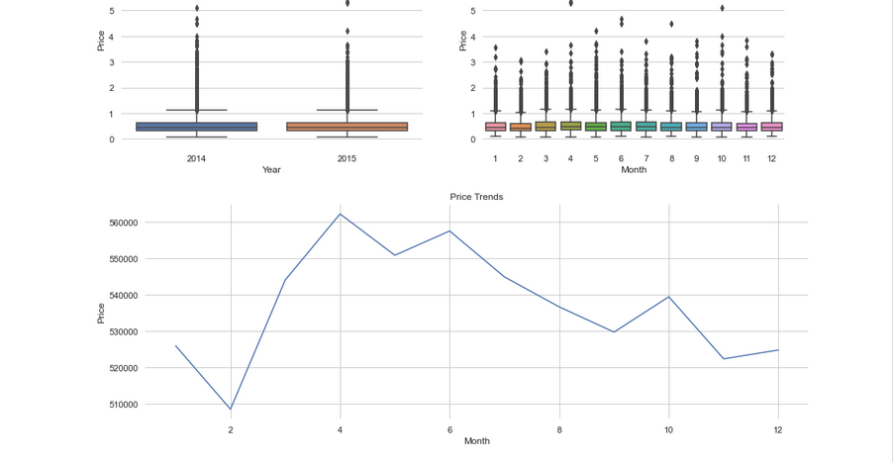

(figure 4.7 EDA 4 )

As we transition from EDA to the next phases of our project, the wealth of information derived from this exploration becomes the bedrock upon which our predictive model is built, emphasizing the pivotal role of thorough data understanding in the success of our endeavor.

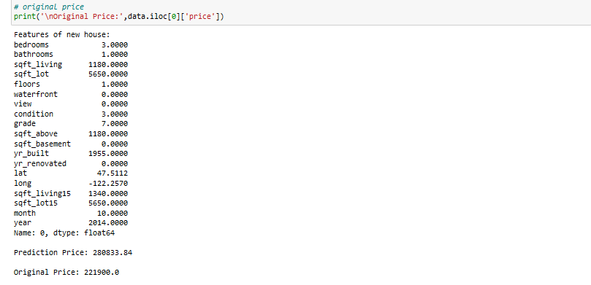

(figure 4.8 price prediction)

the culmination of meticulous data processing, feature selection, and exploratory analysis comes to fruition as we leverage advanced machine learning techniques to forecast house prices.

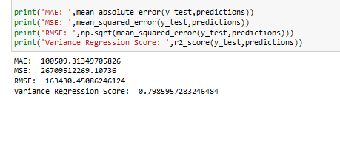

(figure 4.9 accuacry)

As we delve into these accuracy measures, it becomes evident that our model is well-equipped to navigate the complexities of the real estate market, offering users a trustworthy guide in their decision-making process.

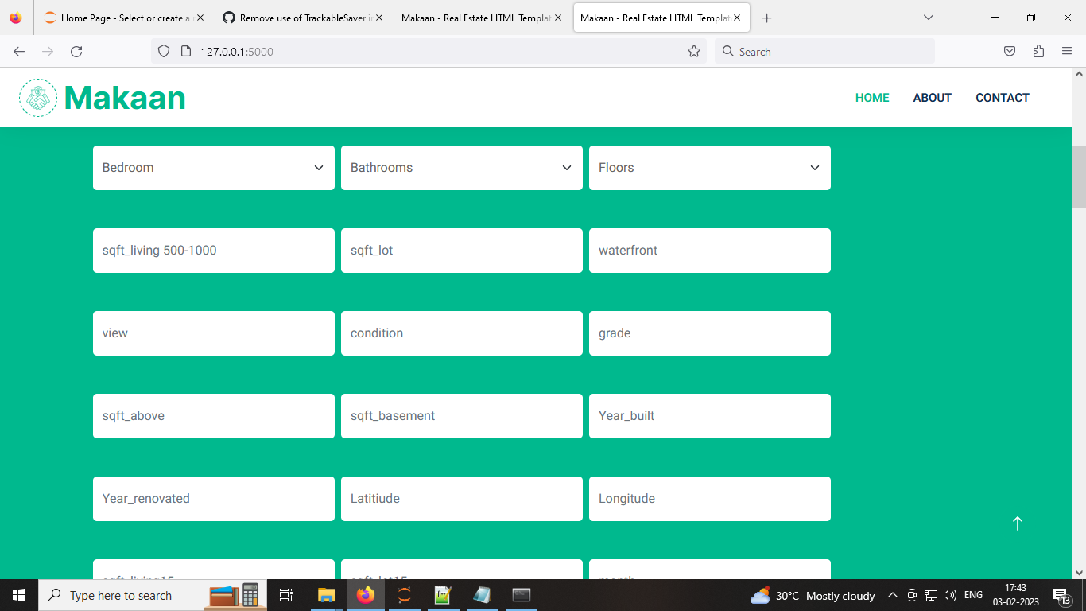

(figure 4.10 User Interface )

Through this intuitive interface, users can seamlessly select the number of rooms, square footage, and various other attributes, tailoring their input to match their unique preferences.

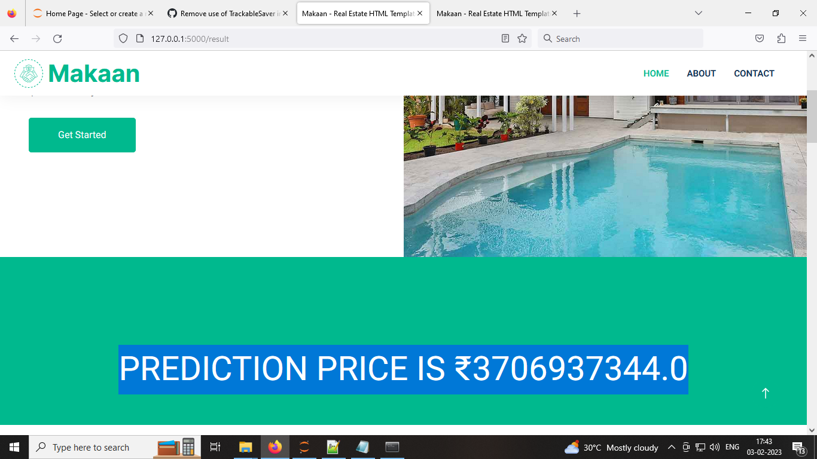

(figure 4.11 final result )

This intuitive results interface ensures that users can easily interpret and leverage the model's insights, fostering a user-centric experience that aligns with our commitment to providing actionable and comprehensible information to potential homebuyers.

**CHAPTER-5**

**CONCLUSIONS**

In conclusion, the "APNA GHAR" house prediction model represents a groundbreaking effort in harnessing the power of machine learning to provide accurate and personalized forecasts in the real estate domain. By integrating traditional property features with individual buyer preferences, our model sets out to redefine the house price prediction landscape. The user-centric approach, allowing potential homebuyers to input specific details ranging from the number of bedrooms and bathrooms to unique choices like waterfront and view preferences, ensures a tailored and precise prediction process.

This project not only focuses on the conventional aspects of property valuation but also emphasizes the dynamic nature of the real estate market. The model's ability to adapt to current trends and incorporate real-time updates based on user feedback contributes to its continuous refinement and relevance.

Utilizing advanced machine learning algorithms, the "APNA GHAR" model aims to capture intricate patterns and relationships within the data, resulting in predictions that are not only accurate but also reflective of the ever-changing landscape of the housing market. By providing explanations for predicted house prices and prioritizing user understanding, trust in the prediction process is enhanced.

In essence, the "APNA GHAR" project strives to empower potential homebuyers with a tool that goes beyond traditional prediction models, considering the nuanced choices and preferences that make each property unique. As we move forward, the integration of cutting-edge technology, user-centric design, and dynamic adaptability positions the "APNA GHAR" house prediction model as a significant contributor to informed decision-making in the dynamic world of real estate.

**CHAPTER-6**

**REFERENCES**

1. L. Breiman, J. Friedman, R. Olshen, and C. Stone. Classification and

Regression Trees, Wadsworth (1984)

2.. J. R. Quinlan, Induction of Decision Trees. Mach. Learn. 1, 1 (Mar.

1986), 81–106 (1986)

1. Guang Cheng, Aiping Zhou, and Hua Wu. Internet Big data mining and

classification. Southeast University Press, 2015.12: 18 (2015)

1. G. K. Kumar, D. M. Rani, N. Koppula and S. Ashraf. Prediction of

House Price Using Machine Learning Algorithms. 2021 5th ICOEI,

* 1. 21)

1. Chakraborty, D.; Sur, U.; Banerjee, P.K. Random Forest Based Fault Classification Technique for Active Power System Networks.
2. In Proceedings of the 2019 IEEE International WIE Conference on Electrical and Computer Engineering (WIECON-ECE), Bangalore, India, 15–16 November 2019.
3. Chang CC, Lin CJ. LIBSVM: A Library for Support Vector Machines. Acm T

Intel Syst Tec. 2011;2(3):27.